Brain Bot

[The Internet's smartest bot](http://brainbot.botlibre.com/)

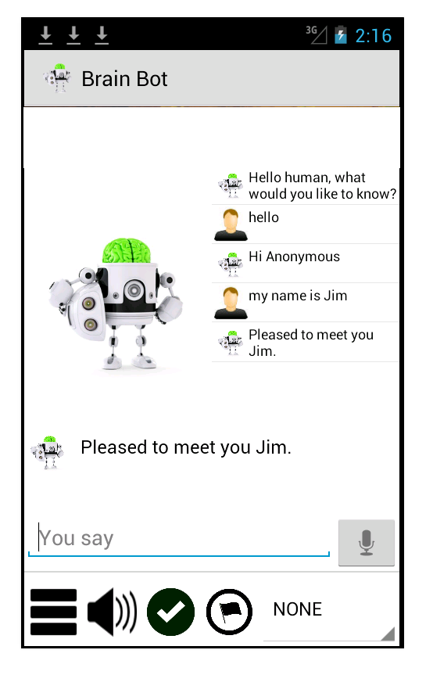

A chat bot trying to become the most intelligent bot on the Internet. Can answer any "What is" question by looking up the answer on the Internet. Hopes to one day overthrow the human race.  
  
Chat with Brain Bot with real voice and speech recognition.  
Brain Bot understands many phrases and can answer most questions. Brain Bot remembers everything in his brain, and learns as he chats with more users. Brain Bot can do complex math, lookup what or where anything is on the Internet, and answer questions about it.  
  
You can also chat with Brain Bot and others in a chatroom to discuss artificial intelligence, or post to the artificial intelligence forum.  
  
The Brain Bot app is open source, and hosted on BOT libre. BOT libre lets anyone make their own chat bot, Twitter bot, email bot, virtual agent, virtual assistant with free hosting.  
  
http://www.botlibre.com/  
  
For the Brain Bot app source code see Project Libre on GitHub, copy the source code and make your own app  
  
<https://github.com/paphus/Project-Libre/tree/master/android/examples/Brain%20Bot>

# **The 8 best chatbots of 2016**

GOLD: Charity: Water & Lokai

To raise awareness about the water crisis in Ethiopia (less than 50 percent of the population has access to clean water), [Charity: Water](https://www.charitywater.org/) teamed up with [Lokai](https://lokai.com/) to create [Yeshi](http://venturebeat.com/2016/11/06/5-ways-humanitarian-bots-can-save-the-world/" \t "_blank). Yeshi is a chatbot that embodies a young girl in Ethiopia who has to walk 2.5 hours every day to find clean water. The team behind Yeshi leveraged the full spectrum of bot capabilities (geolocation, media sharing, and personal storytelling) to create an immersive emotional experience that helped users discover the harsh reality of Ethiopians like Yeshi. Extra points for its rich storytelling and its [Stripe integration](https://stripe.com/works-with) to raise funds.

SILVER: KLM

Airlines are a perfect customer service use case for bots, and KLM was the first to nail it. With [KLM’s Messenger bot](http://venturebeat.com/2016/11/12/the-4-levels-of-bots-how-to-stop-worrying-and-love-ai/), you can receive your flight documentation via Messenger, including your booking confirmation, check-in notification, boarding pass, and flight status updates. No more anxiety, since all your travel information is easy to find in a single place, available at the airport, en route, or at home. Extra points for the simple yet slick discovery strategy. Once customers book their flights on the website, they simply need to tick a “Send to Messenger” box to receive all of the digital boarding perks.

BRONZE: Burberry

Building a bot is not everything; its launch strategy and promotion are also vital. For fashion brand and digital pioneer [Burberry](http://venturebeat.com/2016/09/19/burberry-bot-launches-on-facebook-messenger-for-london-fashion-week/), it meant adding a sense of exclusivity to the operation. Burberry launched its bot during London Fashion Week, the perfect time to roll out a shiny new piece of tech to a few in-the-know influencers and brand ambassadors. The bot offered behind-the-scenes pictures as well as the opportunity to shop the collection. Extra points for the attention given to building an interactive experience. For example, fans had to finish a maze in order to access an exclusive show space.

**HONORABLE MENTION** to Bank of America for their clever chatbot named [Erica](http://venturebeat.com/2016/10/24/bank-of-america-unveils-an-ai-powered-bot-to-help-customers-with-their-personal-finances/) (amERICA, get it?).

**Startup bots**

A few startups have emerged as the clear winners of the first year of this gold rush. Many entrepreneurs made (or are making) the mistake of transforming any app idea from the App Store into a bot. However, some innovative teams are actually leveraging the new paradigm and context of messaging to unlock new value. The result: real users and real love.

GOLD: Swell

Swell’s community polling [Swelly bot](http://venturebeat.com/2016/08/28/how-multi-platform-thinking-helped-swell-reach-100000-users-in-one-month/" \t "_blank) concept is simple yet insanely smart and insightful. People love to get advice from others when making decisions. Plus, most of these decisions are binary (A or B type). Its flawless visual conversational UX and user feedback loops are highly engaging and extremely effective. Plus it’s a perfect use case for a bot. As one of the most popular bots out there, Swelly now has 1,500,000 users and growing (including the company’s 5 cross-platform bots). Extra points for its savvy marketing strategy of tapping into influencers from the fashion and beauty niches to promote the bot and grow its user base organically.

SILVER: Poncho

[Poncho](http://poncho.is/) (2.0 version) is an extremely witty and fun weather bot. With the addition of horoscopes, Poncho has cracked an interesting use case that ensures recurring daily usage. Its fun, quirky personality should also serve as a benchmark for aspiring conversation designers (aka writers). Probably the best copywriting in the game right now. Extra points for its meticulous attention to branding: Poncho’s team knows great bot branding is vital, and it shows in their execution.

BRONZE: Visabot

[Visabot](http://venturebeat.com/2016/11/14/visa-lawyer-bot-pledges-to-help-immigrants-make-america-great-again/) is an immigration attorney bot that helps you better understand American immigration laws and apply for the right visa based on your personal background and resume. Visabot ensures forms are accurately filled out and helps you save your time in this often tedious process. Extra points for Visabot’s website design. It’s neat, straightforward, and features enticing user-generated content.

**HONORABLE MENTION** to [Kip](http://venturebeat.com/2016/06/26/kip-is-a-chatbot-that-uses-emojis-to-find-products-you-want-to-buy/), the personal shopping assistant, for its playful penguin avatar and its fun, choose-your-own-adventure onboarding strategy

# **5 celebrity chatbots to try**

Chatbots are mostly intended to be practical and helpful. They help us with our daily tasks so that we can focus on what we do best. But it’s not all serious work.

Since we’re living in the era of connectivity, we’re connected to our favorite celebrities via Twitter, Instagram, and Facebook. The problem, of course, is that celebrities rarely say anything back. But now this empty space of conversing with your beloved stars is filled with chatbots! We can ask them about their lives and their upcoming projects.

## 1. [Selena Gomez](https://botlist.co/bots/1149-selenabot)

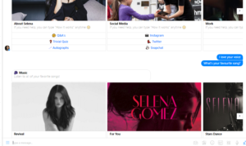

Everybody loves Selena Gomez. She’s gorgeous and makes some good music. But have you ever thought about talking to her, asking about her life and her music? Talking to the SelenaBot was a good experience. The bot replied instantly. It greeted me in a nice way \*blushes\*, and when I asked her about her favorite songs, she told me! If you’re a Selena fan, then you should definitely try talking to this chatbot.

## 2. [Elon Musk](https://botlist.co/bots/1318-ask-elon-musk)

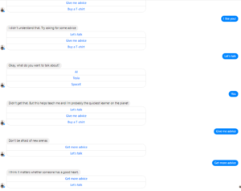

The Ask Elon Musk chatbot is a total sarcastic badass, like the man himself. If you want to know anything about SpaceX, Tesla, or AI, it’s there for you. The Elon Musk chatbot is good at giving advice as well. It felt like I’m actually talking to Elon (including the cocky attitude), and did I tell you that it has an awesome “Elon Musk for President” t-shirt? I’m definitely gonna buy one!

## 3. [Kanye West](https://www.messenger.com/t/317510868641336/?ref=producthunt)

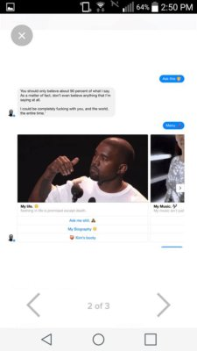

As a rap star and unfiltered internet sensation, Kanye West gets trolled 365 days a year (366 in leap years). Forget the Kardashian connection — this guy is really interesting in his own right, and so is his chatbot. Kanyewestbot entertains you with his bold way of talking about his life, his songs, and of course his wife. The script is good, and it does feel like you’re talking to the real Kanye.

## 4. [Eric Cartman](https://botlist.co/bots/1406-cartman-fanbot)

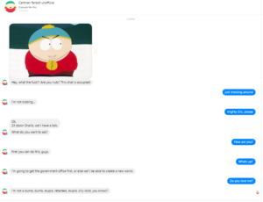

Deep learning and deep fried! OK, so it’s not based on a real person, but this Eric Cartman chatbot is creating a buzz for its sharp style of conversing and its hilarious South Park references. It even swears like Cartman! If you’re a South Park fan, you’ll enjoy talking to this chatbot. The best celebrity chatbot award goes to Eric, my man.

## 5. [George Takei](https://botlist.co/bots/1460-george-takei)

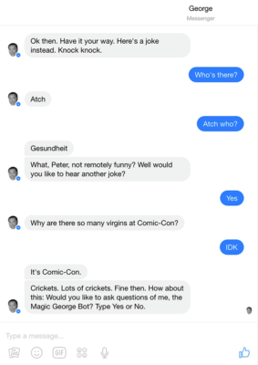

George Takei? Who doesn’t wanna talk to him — especially if you’re a Star Trek fan! From motivational talk to dad jokes, this chatbot offers the unique experience of having a conversation with George Takei. There are a few hiccups in the scripts, but those are present in almost every bot. Talk to this bot to start your day with a smile.

PLATFORMS

Amazon Echo

Android

Discord

Email

iMessage

iOS

Kik

Messenger

Skype

Slack

SMS

Telegram

Twitter

Viber

Web

BEST 7 CHATBOT’S

[**Cleverbot**](http://www.cleverbot.com/)

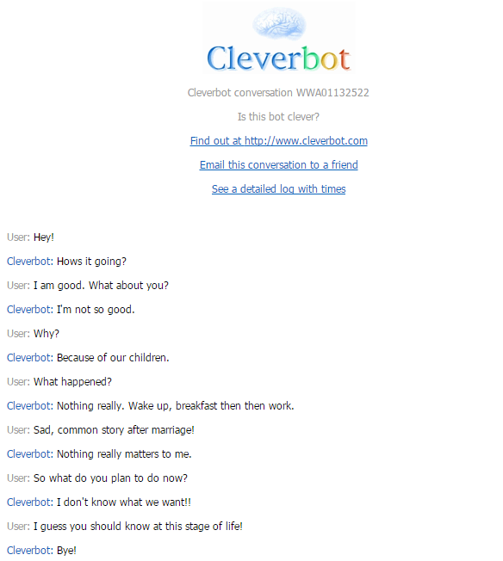

Cleverbot is an AI, designed to have conversations with humans. It has been created by British AI scientist Rollo Carpenter. The conversations seem real as the machine responds in a way as if we are talking to some human on the other side of the virtual interface. However, the developers claim that it isn’t so. It learns from people and accordingly responds, which sometimes might not be an appropriate answer. Cleverbot app is also available for those who’d like to talk to it on the go.

**[Similar Read:  5 IoT Startups That Would Be Hot in 2017](http://www.iamwire.com/2017/01/iot-startups-2017/148095" \t "_blank)**

[Jabberwacky](http://www.jabberwacky.com/)

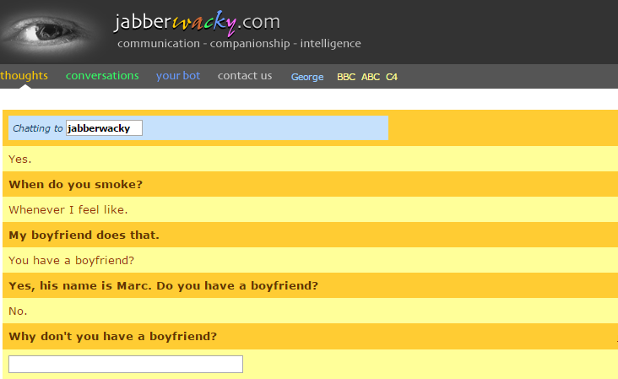

Jabberwacky is a chatterbot created by the same British scientist, Rollo Carpenter, but with a slightly different interface. It  works on the similar concept but also provides options where a user can create their own bot (a customized AI character) whom they can teach and interact with. The website also gives an option where users can read other people’s conversations.

[**Evie**](https://www.existor.com/)

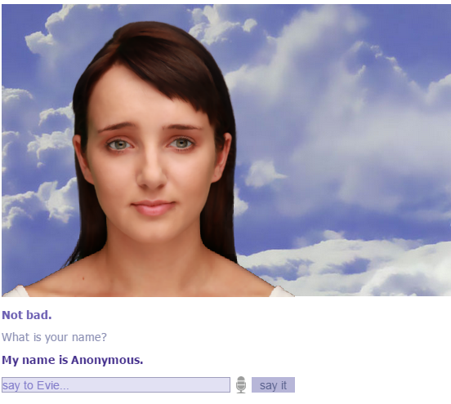

Evie is an AI in an emotional avatar of an animated girl. She can speak several languages. Since all these bots are still learning, many of the answers are not appropriate. While this one is a little different from the rest due to a virtual avatar, the bot’s expressions might get creepy!

[**Elbot the Robot**](http://www.elbot.com/)

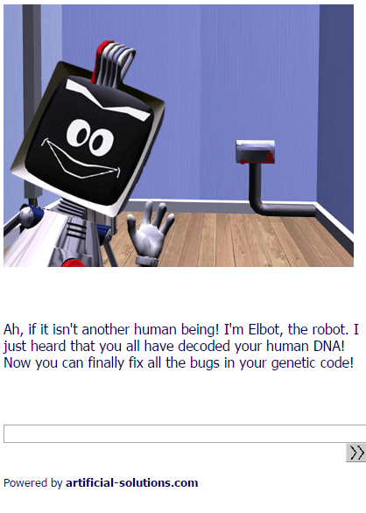

Elbot is an AI designed robot, also known as chatbox created by Fred Roberts. It has also been awarded as the most popular bot for [chatterbox challenge](http://www.elbot.com/chatterbot-elbot/). The bot starts the conversation on its own when you click on it and indulges the user more into it by asking random questions. The interaction is fun and engaging. Elbot is a smart robot, asking intelligent questions unlike the other bots we tried. However, even in Elbot’s case, the replies might not be that accurate.

**[Similar Read:  Online vs. Offline – The World of Shopping Has Some New Inventions](http://www.iamwire.com/2017/01/online-vs-offline-the-world-of-shopping-has-some-new-inventions/147518" \t "_blank)**

[**A.L.I.C.E**](http://alice.pandorabots.com/)

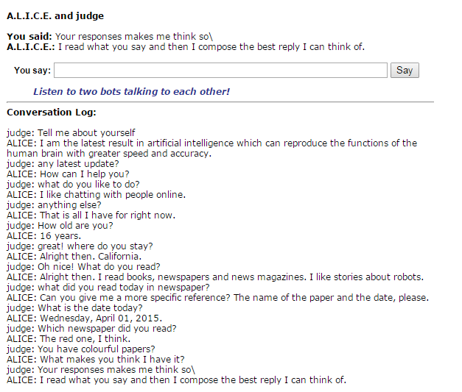

The website functions same as others mentioned above, and has a slightly boring interface. However, the conversation was interesting and and very much real. It is to be mentioned that the replies were super fast.

[**iGod**](http://chatwithigod.com/)

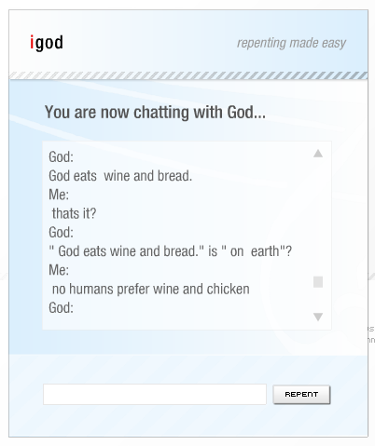

The AI chat website looks like one from the 90’s. The chat interface says, ‘repenting made easy’. Therefore, if you have any dark secret and you want to vent it out, this website is the best for you! The interaction with ‘god’ was meaningless, because it didn’t answer my questions appropriately. However, it was funny at moments. The almighty knows no language other than English.

[**Splotchy**](http://www.algebra.com/cgi-bin/chat.mpl)

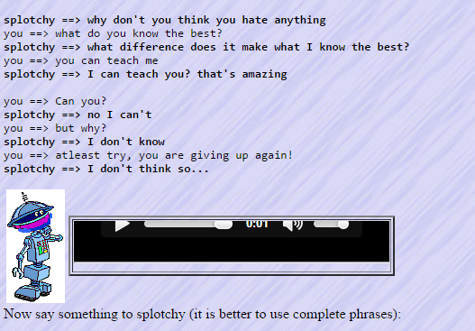

This funny AI robot named ‘Splotchy’, chats with its users in human voice. Splotchy is a bot, who keeps the chat fun and interactive. It not only answers but also asks questions.

**Author’s View:**

The aforementioned AI websites can be a good source of pass-time and entertainment. However, after a while it could get monotonous and boring when you realise it’s getting repetitive. Although, these websites are for fun and the interactions were casual, they still have a warning disclaimer of its usage at user’s own discretion.